**Kafka Installation**

**Prerequisite**

* JDK 1.7+
* Kafka 2.10-0.10.1.1
* Zookeeper 3.4.9

**Installation**

1. **Zookeeper Installation:**

In order to install kafka we need jdk and zookeeper in your system.

1. Download zookeeper from the link.

<http://zookeeper.apache.org/releases.html#download>

1. Goto your Zookeeper config directory. For me its C:\zookeeper-3.4.9\conf
2. Rename file “zoo_sample.cfg” to “zoo.cfg”
3. Open a  command prompt window as admin and change the directory to unzipped folder
4. Run command “.\bin\zkServer”
5. This starts Zookeeper service on port 2181.

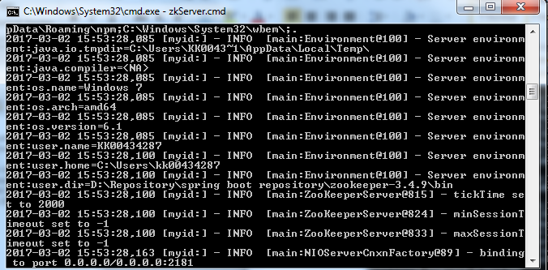

1. **Kafka Installation:**

Important: Please ensure that your Zookeeper instance is up and running before starting a Kafka server.

1. Download kafka from the below link.
   * 1. [**https://kafka.apache.org/downloads.html**](https://kafka.apache.org/downloads.html)
2. Go to your Kafka directory. For me its *C:\kafka_2.10-0.10.1.1*
3. Open a new command prompt window as administrator and navigate to folder ”cd *C:\kafka_2.10-0.10.1.1”*.
4. Run command

“ **.\bin\windows\kafka-server-start.bat .\config\server.properties** ”.

* + 1. 

1. This starts Kafka server.

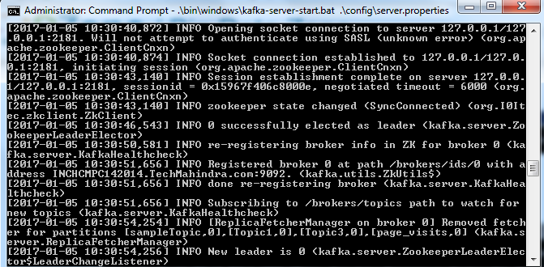

**3. Kafka Topic Creation:**

1. Open a new command prompt as admin and go to kafka folder path *C:\kafka_2.10-0.10.1.1.* Then run the below command and this will create the topic .

**.\bin\windows\kafka-topics --create --zookeeper localhost:2181 --replication-factor 1 --partitions 1 --topic <topic_name>**

**Example:**

**.\bin\windows\kafka-topics --create --zookeeper localhost:2181 --replication-factor 1 --partitions 1 --topic fundTransferRequestTopic**

**And**

**C:\kafka_2.10-0.10.1.1>.\bin\windows\kafka-topics --create --zookeeper localhost**

**:2181 --replication-factor 1 --partitions 1 --topic fundTransferResponseTopic**

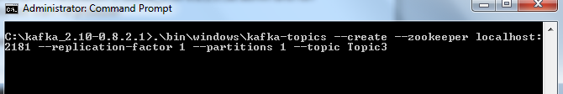

**4. Creating the Producer and Consumer:**

1. Open a new command prompt as administrator in the location C:\kafka_2.10-0.8.2.1\ as admin and run the below command. This will start he producer

**.\bin\windows\kafka-console-producer --broker-list localhost:9092 --topic <topic_name>**

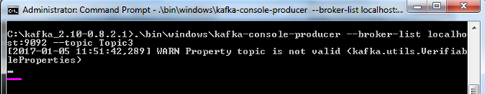

Note : this below step is after creating the consumer.

You can see that the cusor is waiting for the input.if you type the data.

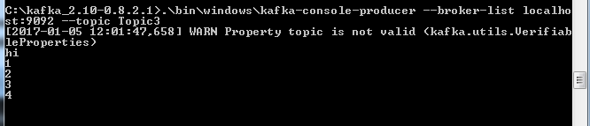

1. Again open a new command prompt as administrator in the same location as C:\kafka_2.10-0.8.2.1\ as admin and run the below command.

**.\bin\windows\kafka-console-consumer --zookeeper localhost:2181 --topic <topic_name> --from-beginning**

Note: you will see this when you enter the data at producer command prompt or it will be empty

Now if you press enter you will see the below window.

